Pro Tour-New York Preview
Gary Wise
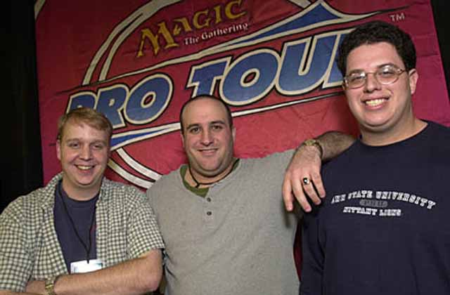
For obvious reasons, New York holds a special place in my heart. One year ago, Mike Turian, Scott Johns and I went to Madison Square Garden with more than three hundred other elite Magic players and we walked away with a $60,000 check. That day, I learned what it was to have your life changed in one amazing moment.
Dare as I do to dream of a repeat, it's going to be a lot tougher this time around. When Andy Heckt, the Pro Tour Player Coordinator, sent me the list of qualified teams for this article, little did I expect to find over six hundred names. Furthermore, I didn't expect that this monumental list would only include those qualified by rating or PTQ victory: in other words, the pro points types who would be qualifying by banding together were missing, so in short, this is going to be one mother of a Pro Tour, and in all likelihood, the largest in the game's history.
With that many teams competing, it's going to require a little bit of luck, stamina, patience, smarts and skill to survive until Day 2, let alone win it all. Here's a look at the basic strategies of the two formats being used in New York, and a few of the teams who have to be considered favorites when using them.

Sealed Deck
In perhaps the most difficult Sealed Deck environment in history, more often than not, teams will have to take the 'wait and see what the packs give us' strategy with gold cards figuring so heavily in Invasion Block. In past events, a team was able to go into the sealed deck portion with a definite idea of how they wanted their completed decks to look. Not any more.
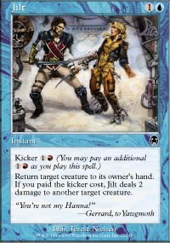
Cards like Jilt are making pros rethink standard strategies
With so many gold cards and monocolor cards like Jilt that require other-colored mana for optimalization, teams are now forced to wait and see where the power lies. If you plan to have three decks, say blue-white-red, green-red-black and black-blue-green and open Crosis, the Purger, suddenly you have a situation where you'll need to adjust your plan for the power card.
The one solution to this problem involves going in with the idea of having a five-color deck. With so many efficient mana fixers in the format, one can almost assume they'll get enough of them to build one solid five-color green or blue deck, meaning that you can build your team's plan around this idea, allowing you to plan out two other decks. If this occurs, it seems more likely than not that the other two decks will be base blue-white and base red-black, with the former adding a third color based on unused multicolor spells while the latter will have the option of going two or three colors, depending on the card pool.
In addition to configuration, the issue teams will have to deal with involves where to put which deck. With teams positioning drafters to play to their strengths, one has to assume that the groundwork for the sealed format is based in those preferences, so if most teams are putting black-red in their A seat, logic dictates that the A player will play the closest deck to red-black that their sealed decks have to offer.
Taking this into account, teams will have to figure out what is best against that red-black while protecting themselves from like-minded attitudes from opponents. The teams that do the best job of this are the ones who are most likely to emerge unscathed from the mess of teams playing on Day 1.

Draft
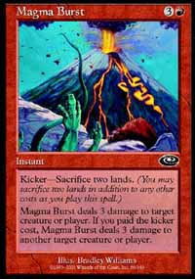
Without betraying too much of the Nation's strategy, again, this portion will come down to what the factory standard for the format is and forming ideas around them. The multi-colored mentality of the format suggests that the C seat will want to cut opponents off from the good stuff in two out of three sets, meaning a lot of teams are putting a base-green deck in C while making sure the A player plays both red and black so as to optimalize the potential of opening Terminate and Magma Burst in three Planeshift packs. This then assumes that the blue-white player sits in seat B.
Of course, with everyone knowing this to be the environment's base, a lot of teams are bound to move away from those ideas in the hopes of capitalizing on them, drafting color strategies that seem strong against those three archetypes. One result of this has been the moving of green in some cases to the middle seat, allowing the green mage to cut power cards two-thirds of the time for each set, while also drafting blue-black, a color that seems well suited to battling the control blue-white offers.
The big question that seems to be being asked is how viable five-color-green actually is, with the weak mana base being especially important in a format where the decks end up being very focused. The teams that answer that question and take advantage of their knowing are the ones to look out for.

The Big Teams
So who are the favorites? Here's a look at those teams with dangerous track records and high-powered individuals that you should be watching this weekend:
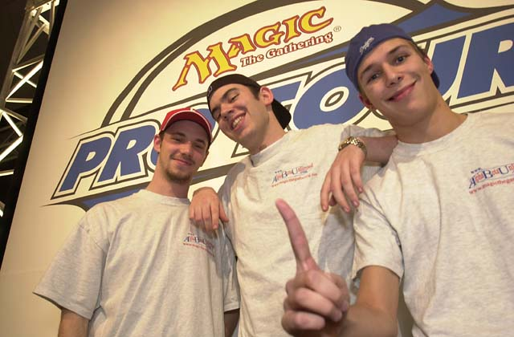
AlphaBetaUnlimited - When the Tokyo Masters Gateway began, Ryan Fuller, Chris Benafel and Noah Boeken were merely a glimmer in the qualified teams' eyes, but a few days later, they each had $20,000 in their pockets for the mere trouble involved in winning the Gateway and then the Masters itself. ABU has made a practice of traveling the planet for team Grand Prix, with Benafel carrying the banner the furthest. Make no mistake: this is the factory original, and won't push over for anyone.
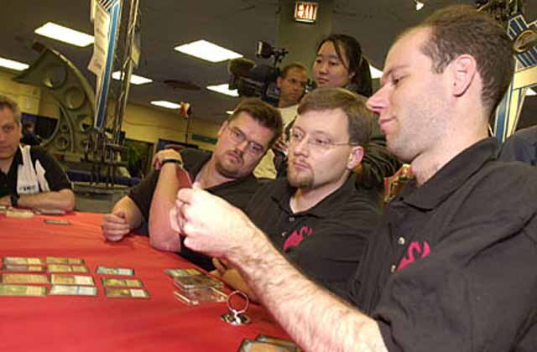
Your Move Games - With the final team GP of the season taking place in Columbus, everyone and their sister showed up, but in the end it was the PT-DC champions who emerged victorious. Darwin Kastle, Rob Dougherty and Dave Humphreys have been together since forever, and as a result their communication is as good as any out there. They have no weak players and get a lot of practice in, meaning that in the end, they have as strong a chance as anyone of taking the title.
Potato Nation - By definition, winning a PT in the format makes a team a favorite, but the reasons go deeper than the 2000 title. I believe that Mike Turian has the strongest understanding of the Team Rochester format on the planet. Scott Johns, Turian and I all finished in the Top 15 of last year's Player of the Year Race, suggesting there are no weak links.
Antarctica - For all their strong finishes, the team of Jon Finkel, Steve O'Mahoney-Schwartz and Dan O'Mahoney-Schwartz still haven't won the big one, and they may have seen their best days go by, with Steve's schooling detracting from his play time. Regardless, Finkel is still Finkel and the OMS boys are both pretty strong players, so the New Yorkers should have a strong showing.
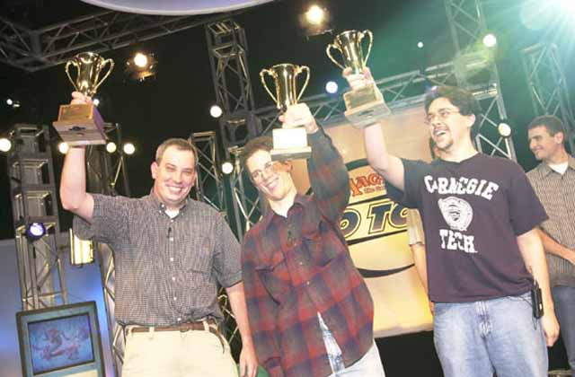
Car Acrobatic Team - A year ago, Pittsburgh set the standard for success in this tournament, with four of the six finalists coming from Team CMU. Andrew Johnson, Aaron Forsythe and Andrew Cuneo breezed through the Swiss portion last year before eventually losing the final to Potato Nation, but by the time they'd lost, they'd earned a lot of respect from their peers. The only question this year is whether they've found a way to break this format.
Black Ops - Antoine and Olivier Ruel have moved beyond their teammate Florent Jeudon in the individual ranks, but the three have always functioned best as a team. Originally coming to the world's attention by winning the Booster Team Challenge a little over a year ago, the Ops finished sixth in New York to reaffirm their standing as a team to beat. None of that changes now.
Here's the best of the rest:
Kai Budde, Dirk Baberowski, Marco Blume - The German Juggernaut brings his buddies out of retirement.
Kamiel Cornelisson, Kyle Rose, Eric Froehlich - The most consistent player in the World teams with a couple of solid Americans.
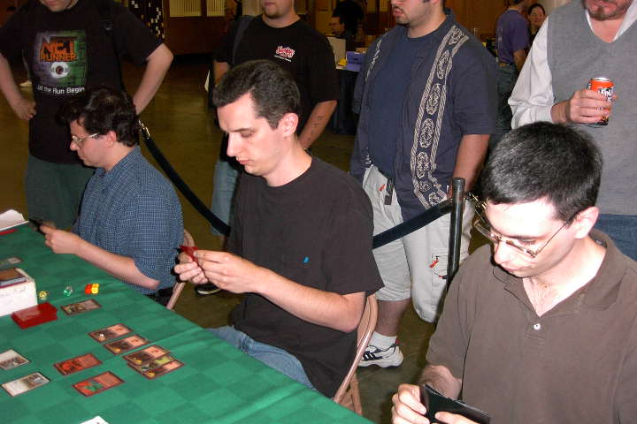
Mike Pustilnik, Gary Krakower, Matt Vienneau - They have the talent, but will they be able to get along for three days?
Zvi Mowshowitz, Alex Shvartsman, Justin Gary - Three old hands team up for a shot at the brass ring.
Dan Clegg, Rod Ho, Lan Ho - The Columbus runner ups look to repeat their strong performance.
Bob Maher, Benedikt Klauser, Igor Frayman - With the recent suspension of Dave Williams, Maher and Klauser picked up Igor.
Tsuyoshi Fujita, Masayuki Higashino, Masaya Mori - Japan's strongest team looks to break new ground
Bram Snepvangers, Jos Scheurs, Menno Dolstra - There are a LOT of Dutch going to New York.
Alan Comer, Brian Selden, Terry Tsang - PT-DC runner-ups Selden and Comer pick up the Canadian Champ.
Patrick Mello, Stephan Valkyser and Peer Kroeger - NY semifinalists Mello and Valkeyser add an old hand to the roster.
Brock Parker, Matt Linde, Billy Jensen - This team more than any would prefer team booster to the selected formats...
Gab Tsang, Brian Hacker, Ben Rubin - ...though these guys wouldn't complain either.

Eivind Nitter, Nicolai Herzog, Bjorn Jacomsen - Last year they came fifth. This year they're aiming a little higher.
Erno Ekebom, Tuomo Niemenen, Tommi Hovi - Finland's finest prefer Limited to Constructed.
Brian Kibler, Dustin Stern, Mike Hron - Five-color Rith is not an impossibility here.
Franck Canu, Raphael Levy, Wilfried Ranque - France's number two team.
Satoshi Nakamura, Kochiro Maki, Kenichi Fujita - The Japanese old school, they almost won the Tokyo Masters Gateway.
Jens Thoren, John Sadeghopour, Tomi Walamies - If only this were European Championships...
Ben Ronaldson, John Ormerod, Ollie Schneider - The new Hampton Court Palace will try to best last year's 9th place finish.
Trevor Blackwell, Mike Long, Brian Hubble - After an awful season, Long is back for one more try.
Corey Ferguson, Dale Taylor, Noah Weil - Time to see if last year's 8th place finish was for real.
Peter Szigeti, Phil Freneau, Brian Hegstad - The Seattle duo trades in T. Tsang for one of the most active players on the GP circuit.
Chad Ellis, Danny Mandel, Peter Vabulous - YMG2's playtesting will be tougher than most of their New York match ups.
Katsuhiro Mori, Itaru Ishida, Osamu Fujita - Ishida's Panzer Hunters are no more, time to start again.

